Tacoma Modern Quilt Guild
October BOM
Background: Kona Ash (supplied)
Colors: Any solid, highly saturated color. Use four different colors or one, two, or three colors.
Cut:
From 2 ½ “ strip of background, cut (4) rectangles @4 ½ “
And (4) 2 ½ “ squares
From colored fabric, cut:
(4) 2 ½ “ squares
(4) 4 ½ “ X 2 ½ “ rectangles
(4) 6 ½” X 2 ½ “ rectangles
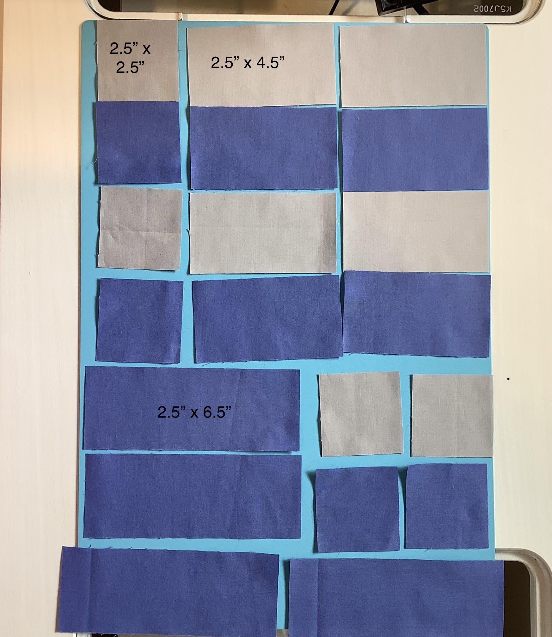
Sew:
One background square to one colored square.
One background 4 ½” X 2 ½” rectangle to one 4 ½ “ X 2 ½ “ colored rectangle
Sew background squares to left of the colored rectangle.
Sew 6 ½ “ X 2 ½ “ rectangle to bottom of squares/rectangle piece.

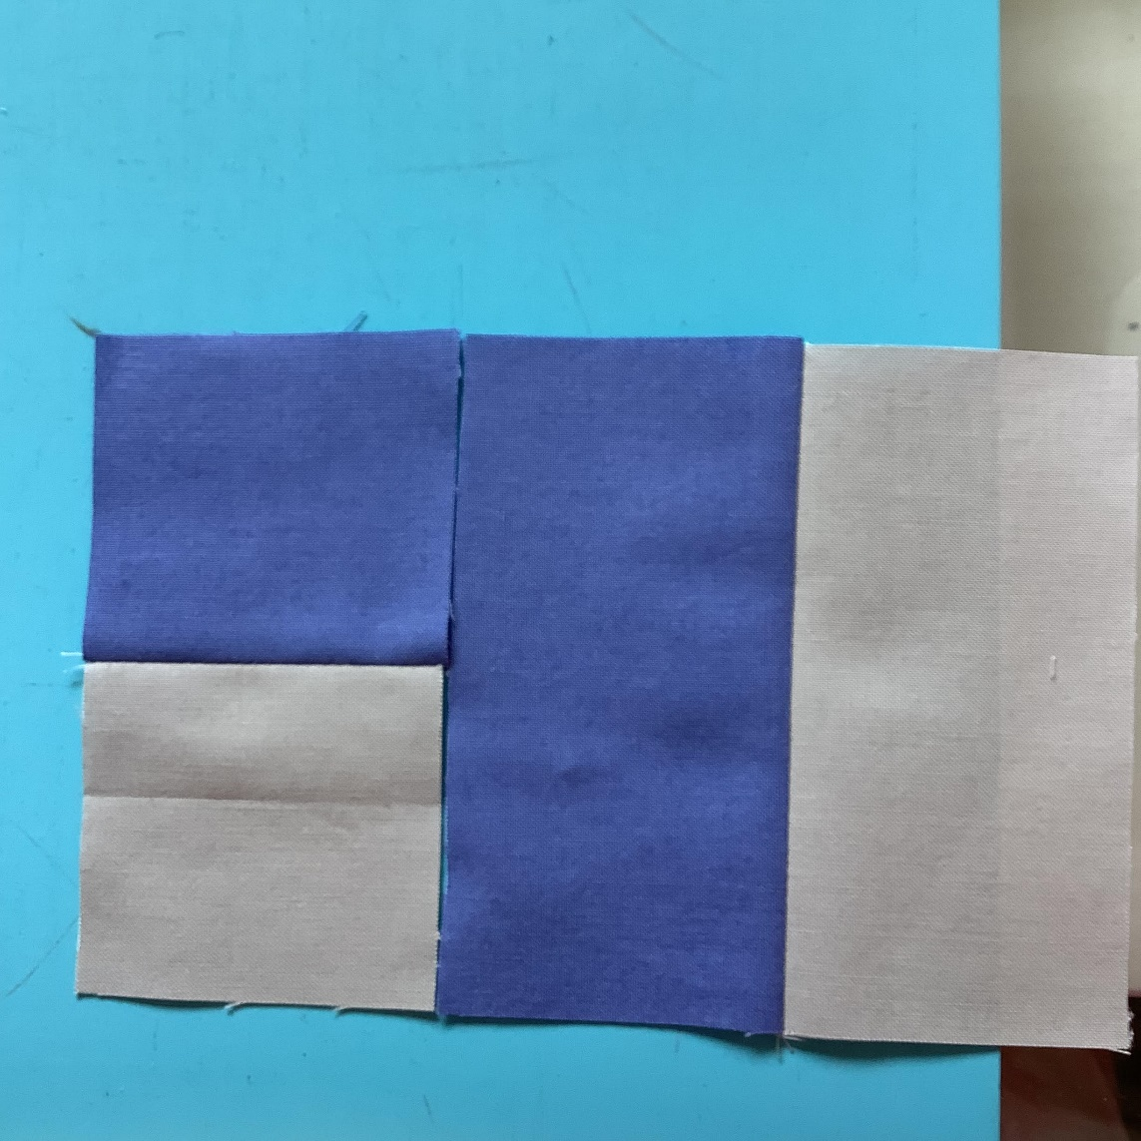

Repeat this step three more times, so that you have four quadrants. Press toward colored fabric.

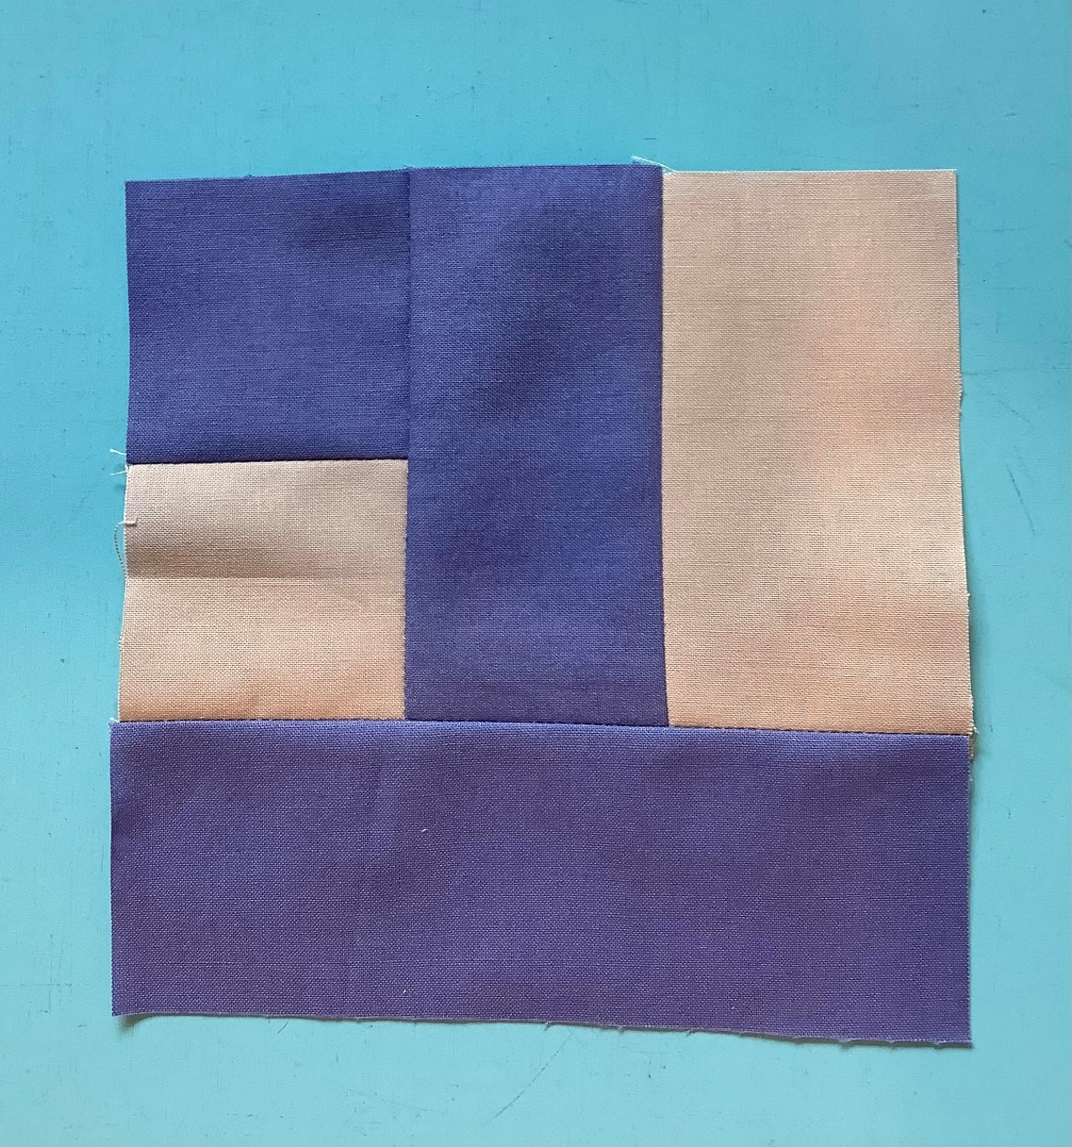

Sew the four quadrants together – be careful that the layout is correct! “Spin” the seams in the center of the block to reduce bulk.

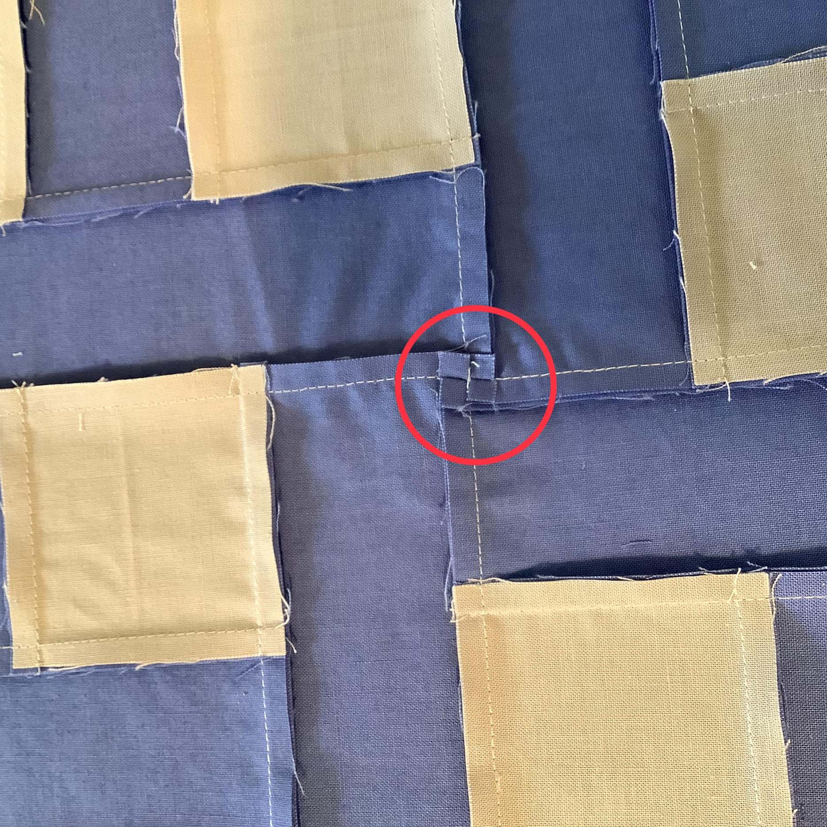

And here is the finished block!

