Duck, Duck, Goose block

Cutting Directions
Cut {4} 3.5″ x 6.5″ rectangles, large geese (I used 2 different colors and cut 2 of each color)
Cut {8} 2″ x 3.5″ rectangles, small geese (I used 4 colors and cut 2 of each color)
Cut {8} 2″ x 3.5″ rectangles, background (I used two colors and cut 4 of each color)
Cut {8} 3.5″ squares (I used two colors and cut 4 of each color)
Cut {16} 2″ squares ( I used two colors and cut 8 of each)

Piecing Directions
This block contains 4 large flying geese and 8 small flying geese. The units are made in the same manner for each size.
Step 1. Draw a diagonal line (wrong side of fabric) down the middle of each 3.5″ square and 2″ square.
Step 2. Take one 3.5″ x 6.5″ rectangle and lay a 3.5″ square on the corner, right sides together. The diagonal line should go from the bottom corner of the rectangle up to the middle. See picture below
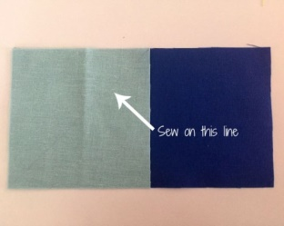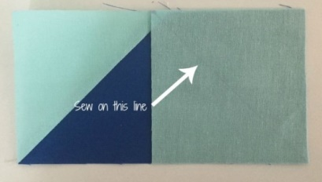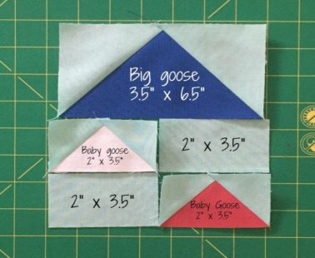
Step 3. Sew on the diagonal line. Step 4. Trim the corner leaving a 1/4″ seam allowance. Step 5. Press the corner.
Step 6. Sew a second square to the other corner. Step 7. Trim this corner leaving a 1/4″ seam allowance. Step 8. Press corner.
You now have one completed 3.5″ x 6.5″ flying goose. Repeat steps 1 through 8 to create 3 more large flying geese and 8 small flying geese. The small flying geese are made using a 2″ x 3.5″ rectangle and 2″ squares on each corner, follow steps 1 through 8 in the same manner with the smaller pieces.
Step 9. Each quadrant of the block is made of 1 large flying goose, 2 small flying geese, and {2} 2″ x 3.5″ rectangles.
